BIOLOGY

Unit 3

2018

Name:

Teacher:

Time allowed for this paper
Reading time before commencing work: ten minutes
Working time: three hours

Materials required/recommended for this paper
To be provided by the supervisor
This Question/Answer booklet
Multiple-choice answer sheet

To be provided by the candidate
Standard items: pens (blue/black preferred), pencils (including coloured), sharpener, correction fluid/tape, eraser, ruler, highlighters

Special items: non-programmable calculators approved for use in this examination

Important note to candidates
No other items may be taken into the examination room. It is your responsibility to ensure that you do not have any unauthorised material. If you have any unauthorised material with you, hand it to the supervisor before reading any further.

Structure of this paper

Section | Number of questions available | Number of questions to be answered | Suggested working time (minutes) | Marks available | Percentage of examination
Section One Multiple-choice | 30 | 30 | 40 | 30 | 30
Section Two Short Answer | 5 | 5 | 90 | 100 | 50
Section Three Extended answer Part A | 2 | 1 | 50 | 40 | 20
Part B | 2 | 1
 |  |  |  | Total | 100

Instructions to candidates

1. The rules for the conduct of the Western Australian Certificate of Education ATAR course examinations are detailed in the Year 12 Information Handbook 2017. Sitting this examination implies that you agree to abide by these rules.

2. Answer the questions according to the following instruction.

Section One: Answer all questions on the separate Multiple-choice answer sheet provided. For each question, shade the box to indicate your answer. Only use a blue or black pen to shade the boxes. If you make a mistake, place a cross through that square, then shade your new answer. Do not erase or use correction fluid/tape. Marks will not be deducted for incorrect answers. No marks will be given if more than one answer is completed for any question.

Section Two: Write your answers in this Question/Answer booklet. Wherever possible, confine your answers to the line spaces provided.

Section Three: Consists of two parts each with two questions. You must answer one question from each part. Tick the box next to the question you are answering.

3. You must be careful to confine your answers to the specific questions asked and to follow any instructions that are specific to a particular question.

4. Additional working space pages at the end of this Question/Answer booklet are for planning or continuing an answer. If you use these pages, indicate the original answer, the page number it is planned/continued on and write the question number being planned/continued on the additional working space page.

Section One: Multiple-choice 30% (30 marks)

This section has 30 questions. Answer all questions on the separate Multiple-choice answer sheet provided. For each question, shade the box to indicate your answer. Use only a blue or black pen to shade the boxes. If you make a mistake, place a cross through that square, then shade your new answer. Do not erase or use correction fluid/tape. Marks will not be deducted for incorrect answers. No marks will be given if more than one answer is completed for any question.

Suggested working time: 40 minutes.

1. Mitotic cell division in a eukaryotic organism should result in

(a) two diploid daughter cells that are genetically identical.
(b) four diploid daughter cells that are genetically identical.
(c) two haploid daughter cells that contain some genetic differences.
(d) four haploid daughter cells that are genetically different.

2. Which of the following statements is true regarding asexual reproduction in prokaryotic organisms such as bacteria?

(a) The daughter cells are always diploid.
(b) Parent cells contain a single chromosome and are therefore haploid.
(c) The genetic information within bacteria can only be passed from parent to daughter cell through cell division.
(d) Genetic variation in bacteria is influenced by crossing over during DNA replication.

3. DNA replication is considered to be semi-conservative. This means that

(a) replication follows strict base-pairing rules.
(b) replication can only occur during specific times in the cell cycle.
(c) new daughter strands are modified during replication to remove ‘junk’ DNA.
(d) new daughter DNA strands are comprised of both parent and new genetic material.

4. DNA is packaged into a tightly coiled, organised structure so that it may fit into the nucleus of a cell. DNA strands are wrapped around a histone protein complex to form the basic units of DNA packaging, termed

(a) chromatin.
(b) nucleosomes.
(c) chromosomes.
(d) nucleotides.

5. The DNA molecule is distinguished by four different nitrogenous bases, represented by the letters A, T, C and G. These letters stand for

(a) adenine, thymine, cytosol and guanine.
(b) adenine, thyroxin, cytosine and glutamine.
(c) adenine, tyrosine, cytosol and glutamine.
(d) adenine, thymine, cytosine and guanine.

6. DNA bases have a specific complementary pairing system that forms the ‘rung’ in the double helix. If one strand of DNA has the sequence AATGGCCAT, then its complementary strand will read

(a) AATGGCCAT.
(b) TTACCGGTA.
(c) CCGAATTGC.
(d) TACCGGTAA.

7. The phase of the cell cycle in which DNA is replicated is called

(a) anaphase.
(b) telophase.
(c) synthesis phase.
(d) interphase.

8. Which of the following best describes an allele?

(a) A pair of homologous chromosomes containing complementary genes.
(b) The genotype of a given genetic trait.
(c) An alternate version of a gene found at the same loci.
(d) The heterozygotic form of a genotype.

9. Intelligence in humans is controlled by a number of different genes. Intelligence is therefore
(a) controlled by multiple alleles.
(b) polygenic.
(c) an example of continuous variation.
(d) a genetically complex trait.

10. Mendelian genetics shows the patterns of inheritance in sexually reproducing organisms. It is widely accepted that the phenotypic ratio of a monohybrid F₁ cross is

(a) 1 : 2 : 1
(b) 1 : 2
(c) 1 : 3
(d) 3 : 1

11. A strawberry farmer wanted to grow plants that produced fruit with no external seeds. He cross-pollinated a mutated, seedless form with a normal strawberry plant. The phenotypic ratio of the F₁ generation was 1 : 1. Which statement best explains this outcome?

(a) Seedless fruit is recessive and seeded fruit is dominant, with the genotypes being homozygous and heterozygous, respectively.
(b) Seedless fruit is the recessive trait, however, a greater number of alleles exist in the gene pool.
(c) Seedless fruit is dominant over seeded fruit with both genotypes being homozygous.
(d) Further research is required to make a valid judgement.

12. The phenotype of an organism is the result of

(a) mutations and independent assortment.
(b) genotype and interactions with the environment.
(c) chemical interactions with the cytoplasm.
(d) mutations and sexual dimorphism.

13. When both alleles are fully expressed in the phenotype of the offspring the characteristic is known as

(a) pseudo-dominance.
(b) a genetic anomaly.
(c) co-dominance.
(d) non-recessive inheritance.

Use the information below to answer questions 14 and 15.

An experiment was devised to reveal the mechanism/s by which height is expressed in different varieties of tomato plants. Three types of tomatoes were grown from seed in identical conditions in a greenhouse over a period of eight weeks. The results from this experiment are shown in the histograms below.
Phenotypic frequency
Phenotypic frequency
Red cherry tomatoes
Yellow cherry tomatoes
Roma tomatoes
Phenotype
Phenotype
Phenotype
Phenotypic frequency

14. Given the pattern of growth shown in the results, what is the most likely mechanism controlling plant height in the Roma tomatoes?

(a) Multiple alleles.
(b) Polygenic inheritance.
(c) Mendelian inheritance.
(d) Photosynthesis.

15. Whilst inside the greenhouse, variables that must be controlled in this investigation include

(a) soil type, amount of water and addition of nutrients.
(b) amount of water, timing of plant measurements and pot size.
(c) pot size, seed depth and position in the greenhouse.
(d) all of the above.

16. Which of the following does not reflect convergent evolution?

(a) Spines on an echidna and a porcupine.
(b) Horns on a rhinoceros and a chameleon.
(c) A grey wolf and a greyhound.
(d) Pectoral fins on a fish and a dolphin.

Use the information below to answer questions 17 and 18.

Riversleigh is a well-known location in Queensland rich in fossil deposits. During a dig, a palaeontologist discovered the skull of an ancient species of koala, estimated to be around 40 000 years old. At a deeper level the remains of a chicken-sized dinosaur was also uncovered.

17. Which of the following radioisotope methods would be most effective for estimating the ages of the dinosaur and koala remains, respectively?

(a) Carbon-14 for both sets of remains.
(b) Carbon-14 and Uranium-235.
(c) Uranium-235 for both sets of remains.
(d) Uranium-235 and Carbon-14.

18. The dinosaur remains were found in rock that was imprinted with the details of its body covering. For these details to be preserved, the conditions at the time of fossilisation must have been

(a) anaerobic and undisturbed.
(b) acidic and moist.
(c) moist and oxygenated.
(d) moist and volcanic.

19. The diagrams of the rock strata below represent fossils found at three different locations.
B
A
C

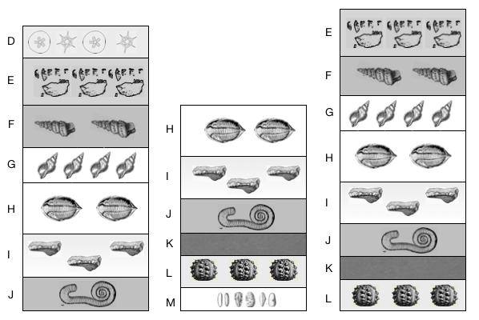

Which strata profile contains the oldest fossils?

(a) A
(b) B
(c) C
(d) They are all the same age.
20. Following analysis of the genomes of 300 Panther chameleons (Furcifer pardalis) on the island of Madagascar, scientists have concluded that the genetic variability was such that what was previously thought to be one single species should be 11 new species. This is the result of

(a) allopatric speciation.
(b) sympatric speciation.
(c) random genetic drift.
(d) sexual selection.

21. A significant reduction in the genetic variation of a small, newly isolated population is referred to as

(a) genetic variance.
(b) the founder effect.
(c) gene flow.
(d) the bottleneck effect.

22. The pattern of evolution as shown in the fossil record reveals long periods of evolutionary stasis with short bursts of relatively rapid speciation. This pattern of evolution is known as

(a) punctuated equilibrium.
(b) variable evolutionary change.
(c) divergent evolution.
(d) transitional speciation.

Use the information below to answer questions 23 and 24.

The diagram below shows a segment of DNA with a total length of 3200 base pairs. The arrows indicate the position at which restriction enzymes cleave the DNA molecule.

G

F

E

DNA segment
280
900
1600
length (base pairs)
3200

23. If restriction enzyme G became denatured during the experiment, the length of the resulting base-pair segments would be

(a) 280, 620, 700 and 1600.
(b) 900 and 2300.
(c) 1600 and 1600.
(d) 280, 620 and 2300.

24. Which of the following ‘gels’ correctly reflects the action of restriction enzyme F?

(a) (b)

(c) (d)

Base  Pair | Marker | Sample
4000
3200 | cccc
2300 |  | ccccc
1600
900 |  | ccccc
700 | ccccc
620 | ccccc
280 | ccccc

Base  Pair | Marker | Sample
4000
3200 | cccc
2300 |  | ccccc
1600
900
700 | ccccc
620 | ccccc | ccccc
280 | ccccc

Base  Pair | Marker | Sample
4000
3200 | cccc
2300 |  | ccccc
1600
900
700 | ccccc
620 | ccccc | ccccc
280 | ccccc | ccccc

Base  Pair | Marker | Sample
4000
3200 | cccc
2300
1600 |  | ccccc
900 |  | ccccc
700 | ccccc
620 | ccccc
280 | ccccc | ccccc

25. Analogous structures of different species of animals

(a) reveal common ancestry.
(b) are similar in structure and function.
(c) are similar in structure but not function.
(d) have the same function but a different structure.

26. Within any species, individual organisms show genetic variability. Which of the following processes provides the foundation for this variability?

(a) Asexual reproduction.
(b) Meiosis.
(c) Mitosis.
(d) Genetic drift.

27. Which of the following best describes the purpose of comparative embryology?
Comparative embryology

(a) identifies similarities in the fossilised forms of ancient embryos.
(b) identifies common ancestry by comparing the stages of embryonic development of different animal groups.
(c) involves the comparison of the embryonic structures, of different animal groups, to their adult forms.
(d) describes the differences in reproductive processes between species.

28. The pectoral fin of a whale and hand of a chimpanzee are considered homologous structures. This means that

(a) they have an identical anatomic structure.
(b) whales evolved from chimpanzees.
(c) they have a similar structure as a result of natural selection.
(d) they have a similar structure but a different function.

Use the following image and information to answer question 29.

The photograph below is a representative model of Archaeopteryx, an ancient species with the characteristics of both birds and reptiles.

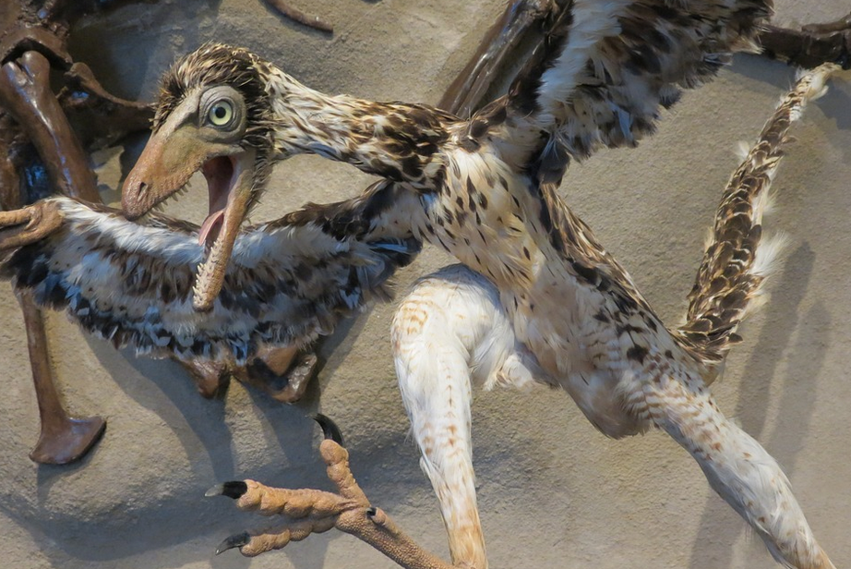

29. Archaeopteryx is an example of

(a) a well-preserved fossil.
(b) a transitional form.
(c) a convergent species.
(d) punctuated equilibrium.

30. Genetically engineered salmon is being successfully sold in Canada after approval by authorities. Genes from another species of salmon and an ocean pout have been inserted into the GE salmon’s DNA. These genes both accelerate and maintain the growth rate of the salmon until they are harvested. The engineered salmon are sterile, grow twice as fast as regular salmon and consume 25% less food. While environmental activists still oppose the sale of the salmon, genetically modified food like this may be beneficial to the world’s growing populations because it

(a) provides a more sustainable method of obtaining fish protein.
(b) contains elevated levels of growth hormone that could help malnourished children in impoverished communities.
(c) enhances the economic growth of the genetic engineering company.
(d) could pass its newly altered genome onto the ‘wild’ form of the species, increasing the quality and quantity of natural salmon populations.

End of Section One
Section Two: Short answer 50% (100 marks)

This section has five (5) questions. Answer all questions. Write your answers in the spaces provided in this Question/Answer booklet. Wherever possible, confine your answers to the line spaces provided. Use a blue or black pen for this section. Only graphs and diagrams may be drawn in pencil.

Additional working space pages at the end of this Question/Answer booklet are for planning or continuing an answer. If you use these pages, indicate at the original answer, the page number it is planned/continued on and write the question number being planned/continued on the additional working space page.

Suggested working time: 90 minutes.

Question 31 (20 marks)

(a) Outline the function of each type of RNA molecule in the table below. (4 marks)

Type of RNA molecule | Function of RNA molecule in the cell
mRNA
tRNA
rRNA
miRNA and siRNA

(b) Describe the role of RNA polymerase in a eukaryotic cell. (3 marks)

A teacher tells his students that RNA polymerase is the most important molecule in the cell.

(c) Based on its role in a eukaryotic cell, justify the teacher’s statement regarding the importance of RNA polymerase to cellular function. (2 marks)

(d) Name the process that is occurring in the diagram below. (1 mark)

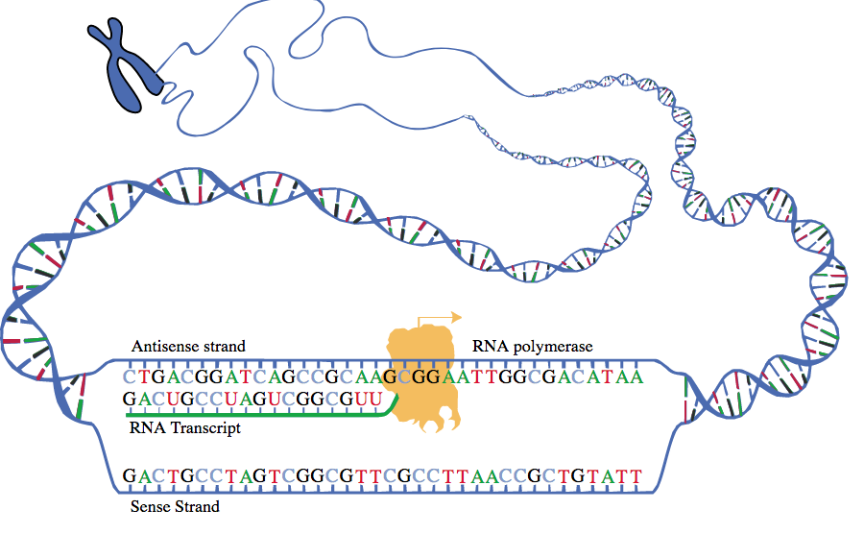

E

A
C

D

B

(e) Identify the structure on the diagram above at the areas labelled A – E. (5 marks)

A:

B:

C:

D:

E:

(f) Distinguish between the structures labelled A and B. (2 marks)

(g) Describe the effect that mistakes (in the process shown in the diagram) may have on subsequent cellular processes. (3 marks)

Question 32 (20 marks)

Genetically modified organisms are able to express desired traits (as proteins) that would otherwise be absent from their DNA. Genes can be transferred from one organism to another using recombinant DNA technology and gene cloning. Specific bacterial cells are readily utilised in these processes.

(a) Outline four (4) characteristics of bacterial cells that make them ideal for transferring and cloning genes. (4 marks)

(b) Define the following terms in relation to their role in recombinant DNA technology.
(4 marks)

Restriction enzyme:

DNA ligase:

Sticky ends:

Recombinant plasmid:

(c) Identify the structure and/or process at points labelled (i) – (iv), on the diagram below. (8 marks)

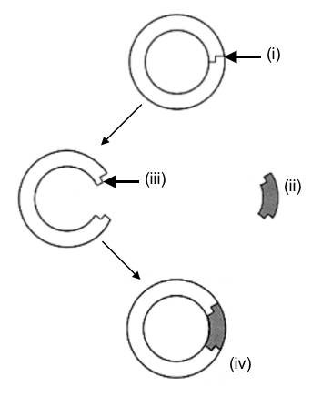

(i)

(ii)

(iii)

(iv)

(d) Identify four (4) successful outcomes for modern science that have used gene transfer technology. (4 marks)

Question 33 (20 marks)

The Red-tailed Phascogale (Phascogale calura) is a small, carnivorous marsupial belonging to the family Dasyuridae. Once widespread throughout Australia, it is now restricted to isolated pockets in southwest Western Australia and considered vulnerable to extinction.

The Red-tailed Phascogale is characterised by an unusual reproductive strategy. Both males and females have multiple mating partners during their limited three-week breeding season during winter. Female phascogales can store sperm in their oviducts for up to five days. They can produce up to three litters (8-13 babies) during their short, three-year lifespan. In contrast, male phascogales must make the most of their first breeding season, as they die shortly after mating. During this single, narrow breeding period, male phascogales must therefore maximise their investment in reproductive success.

Research has shown that while male Red-tailed Phascogales live longer in captivity, they do not continue to produce viable sperm following the first breeding season. Female phascogales on the other hand may live up to five years in captivity but following the first breeding season, produce litters with significantly fewer offspring that have a significantly lower survival rate.

(a) Explain how the isolated populations of Red-tailed Phascogales are able to maintain their genetic diversity, given their short life span. (4 marks)

(b) Identify three (3) possible causes for the decline of Red-tailed Phascogales in Australia.
(3 marks)

(c) Captive breeding programs have been effective at restoring populations of endangered animals. Suggest three (3) considerations that should be made if phascogales were to be bred in captivity. (3 marks)

A PhD student was interested in determining the paternity of the offspring from a litter of Red-tailed Phascogales.

(d) Briefly explain the procedures she must follow in order to profile and visualise the DNA of the phascogales in question. Diagrams may be used if required. (8 marks)

(e) Suggest two (2) other areas of species or ecosystem conservation to which this biotechnology can be applied. (2 marks)

Question 34 (20 marks)

Mutations are the raw material of evolution. Without mutations, life on Earth would be vastly different and much less diverse.

(a) Define the following types of mutations that can occur at the gene or chromosome level. (10 marks)

Substitution:

Deletion:

Insertion:

Inversion:

Duplication:

(b) Identify two (2) factors that cause or increase the incidence of mutations. (2 marks)

(c) Identify the difference between somatic mutation and germ-line mutation. (2 marks)

(d) Describe the effect of somatic mutations compared to germ-line mutations on an organism. (4 marks)

(e) Explain why a mutation can influence the evolution of a species. (2 marks)

Question 35 (20 marks)

Red-green colour blindness is a recessive, sex-linked genetic trait, which can occur in humans.

(a) Explain the difference between a sex-linked trait and an autosomal trait. (4 marks)

(b) Identify the possible genotypes and phenotypes of the offspring that may be produced from a female who is heterozygous for the trait and a male who is affected by red-green colour blindness. The dominant allele is R and the recessive allele is r. (8 marks)

Genotypes:

Phenotypes:

(c) Explain why more men are affected by red-green colour blindness than women. (2 marks)

Advances in biotechnology have enabled scientists to clone cells. An organism’s own stem cells can be harvested and genetically modified to remove a faulty gene. The modified cells are cultured and reinserted into the required location in the organism.

(d) Suggest three (3) positive and three (3) negative aspects of cloning in this manner. (6 marks)

Positive aspects:

Negative aspects:

End of Section Two

Section Three: Extended answer 20% (40 marks)

This section contains four (4) questions. You must answer two (2) questions; one (1) from Part A and one (1) from Part B.

Use a black or blue pen for this section. Only graphs and diagrams may be drawn in pencil. Responses can include: labelled diagram with explanatory notes; lists of points with linking sentences; labelled tables and/or graphs; and/or annotated flow diagrams with introductory notes.

Additional working space pages at the end of this Question/Answer booklet are for planning or continuing an answer. If you use these pages, indicate at the original answer, the page number it is planned/continued on and write the question number being planned/continued on the additional working space page.

Suggested working time: 50 minutes

Part A

Choose either Question 36 or Question 37.

Indicate the question you will answer by ticking the box next to the question. Write you answer on pages 23 - 25. When you have answered your first question, turn to page 26 and indicate the second question you will answer on that page.

Question 36 (20 marks)

(a) DNA is the blueprint of life. Describe the unique structure of DNA and how it is packaged to enable large amounts of information to fit inside a eukaryotic cell.
(10 marks)

(b) Explain the process of DNA replication. (10 marks)

Question 37 (20 marks)

(a) Discuss the ‘genetic code’ and its relationship with the production of proteins.
(10 marks)

(b) Describe the process of meiosis in a multicellular, eukaryotic organism. Indicate the mechanisms that occur to increase the genetic variability in a species. (10 marks)

Question number

Part B

Choose either Question 38 or Question 39.

Indicate the question you will answer by ticking the box next to the question. Write your answer on the pages provided.

Question 38 (20 marks)

It is well known by evolutionary biologists that domestic dogs evolved from ancestral wolves. Scientists have discovered that these wolves may have carried genetic mutations that made them more sociable with humans of the time. A team of researchers have sequenced the region in both the domestic dog and wolf genome previously identified as playing a role in sociability. Mutations were found on the genes GTF21 and GTF21RD1, known to be responsible for hyper-sociability in humans. It was suggested that ancestral wolves carrying the mutations might have been friendlier to humans and therefore easier to domesticate.

(a) Discuss how domestic dog breeds have been developed over time and compare this process to the factors that contribute to the theory of evolution through natural selection. (10 marks)

(b) Identify and describe the techniques used to identify the presence and location of the base sequence of the mutated genes (GTF21 and GTF21RD1) under investigation. (10 marks)

Question 39 (20 marks)

(a) “PCR is an ecologist’s best friend”.

Justify this statement in relation to conservation ecology. Describe how PCR can be used in studying genetic diversity of a single species over a broad range of geographic and environmental conditions. (10 marks)

(b) The fossil record reveals numerous patterns of rapid speciation, followed by long periods of evolutionary stability. These events have often coincided with significant changes in the geology or geography of Earth. Discuss the mechanisms that drive this pattern of evolution, using examples to support your answer. (10 marks)

Question number

Acknowledgements

Question 14
Author constructed

Question 19
Author constructed
Wikimedia commons images

Question 22
Author constructed

Question 24
Author constructed

Question 29
https://pixabay.com/en/users/Raw2daBon3-3213132/
Creative Commons CCO

Question 31
Wikimedia Commons

Question 32
Author constructed

